Ryo Yonetani

(Assistant Professor /   
The University of Tokyo)

* First-Person Vision
* Visual Saliency

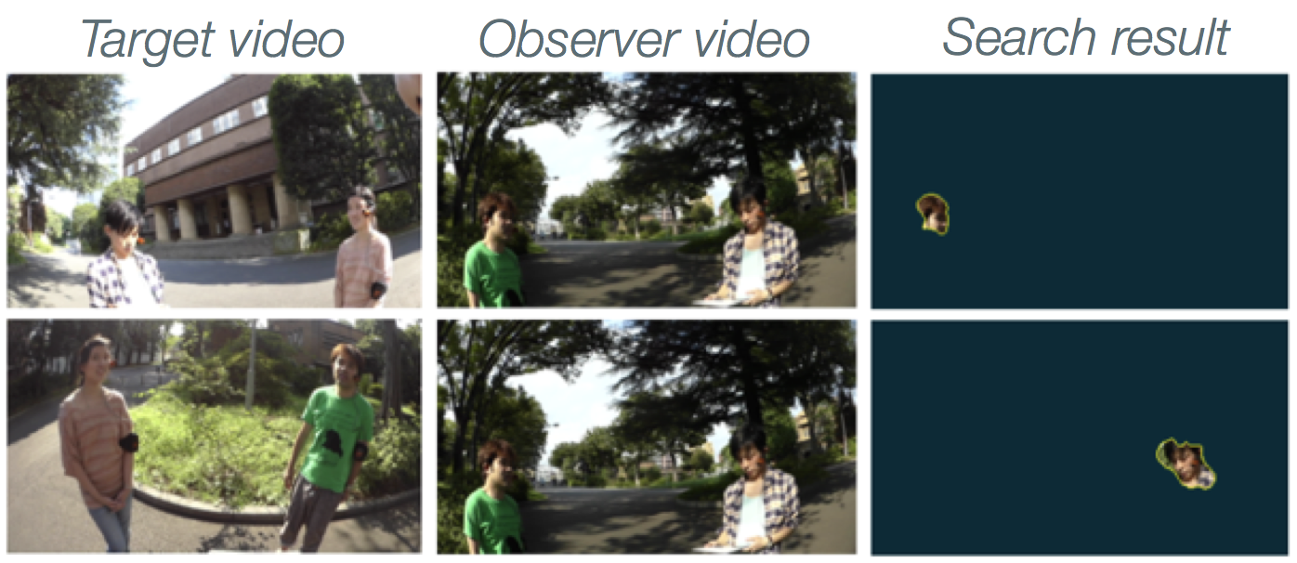

Ego-Surfing First-Person Videos (CVPR’15)

